# North of Tyne Project Integrated Energy System Model

**Authors: Robin Wardle, Adib Allahham, Hamid Hosseini, Sarah Sheehy, Haris Patsios, Laura Brown, Jannetta Steyn**

**Update: 31/03/2020**

## Introduction

This document describes the North of Tyne (NoT) Project integrated energy system model and proposed analysis topics and approaches. The NoT Project aims to analyse the contribution that considered development of distribution energy network infrastructure can make to the North-East region’s carbon reduction scenarios. To do this, a portion of the North of Tyne region’s gas and electrical networks have been selected as an exemplar case study and modelled for use in scenario and uncertainty analysis to support low-carbon transition decision-making.

The model consists of data specifying the topology, physical properties and behaviour and structure of the networks, analysis software written in the MATLAB scientific programming language, and sample customer-level energy demand data. This document will describe these components along with the opportunities, limitations and constraints that the model format provides.

Glossary

**BESS** – Battery energy storage system, a device connected to the electrical network which is able to convert electrical energy to and from chemical energy.

**Branch** – A component of a network which connects and distributes energy between the network nodes.

**Co-Production** – The simultaneous production of more than one energy vector by an engineering device.

**Combined Heat and Power** – A device (commonly an internal combustion engine supplied with liquid or gaseous fuel) which co-produces electricity and heat for useful consumption.

**Demand** –The rate of energy supply (power, in kW) that a consumer requires from the network. For the NoT project, energy is supplied as gas (a proxy for heat), or electricity. Demand energy leaves the network.

**Demand, Typical** – The energy demand for an individual energy consumer type. An individual consumer is assumed for convenience to have been allocated to a type or class of consumers that most represents that consumer’s demand patterns. For electricity consumers, demand for a specific MPAN is typified by its ELEXON profile class.

**Demand, Representative** – A demand profile taken to be representative of the consumer demand at an aggregated network supply point, for particular days of interest to system designers or analysts. For electricity consumers, this is constructed through an aggregation method designed within the North of Tyne IES project. For gas consumers, nodal supply point demands are provided to the North of Tyne IES project by industrial modelling and simulation.

**Distributed Energy Supply**– Energy injected into the network from a standalone energy supply device. See also **grid supply**.

**Efficiency** – A quantity characterising the effectiveness of an engineering device, defined as the ratio of energy produced by the device to the energy consumed by the device. Efficiency values lie between zero and one.

**Electrolyser** – See **power-to-gas.**

**ELEXON** – A private business which compares the amount of electricity declared to be produced or consumed by generators and suppliers with the amounts actually produced or consumed. ELEXON brokers the price for any differences and transfers monies accordingly.

**ELEXON Profile Class** – Diurnal half-hourly average power consumption that is taken to be typical of a group of similar electricity consumers. There are eight classes, with each electricity consumer in the UK being assigned to one class. Each class consists of five demand profiles which typify a seasonal archetype: spring, summer, high summer, autumn and winter. The data used to construct the class profiles are compiled from sampled metered data.

**Energy Conversion** – The physical process of converting an energy property from one value to another, either in the same domain or to a different domain. For example, electrical energy can be converted to electrical energy at a different voltage level, or to another form of energy altogether (e.g. heat).

**Energy Domain** – The physical phenomenon carrying usable energy, e.g. thermal, electrical, chemical, mechanical.

**Energy Storage** – An engineering device which can temporarily store energy flowing in the energy network in a more stable form. The device usually converts energy (such as electricity) into something more convenient or energy dense, such as chemical energy (e.g. lithium-ion cells), mechanical energy (e.g. a flywheel), and so on. This stored energy is re-converted into a transmissible form later for some useful purpose.

**Energy Vector** – see **energy domain.**

**Grid Supply** – Energy injected into the network from another network. This supply grid also supplies networks other than the one of interest. See also**distributed energy supply**.

**Integrated Energy System** – An energy system consisting of more than one energy vector, along with devices that can convert energy between the vectors. Also sometimes just referred to implicitly as an **integrated system**.

**Load** – See **demand**

**Lower-layer Super Output Area (LSOA)** – A geospatial unit in the output area classification scheme designed to improve the reporting of small area statistics in England and Wales. Lower-layer super output areas are automatically generated from output areas and the generation algorithm attempts to make them as consistent in population size as possible. Typically LSOAs contain from four to six Output Areas. The minimum population of a LSOA is 1000 and the mean population is 1500. See **Output Area**.

**MPAN** – Meter Point Administration Number; a 21-digit reference number used to uniquely identify an electricity supply point. See also **MPRN**.

**MPRN** – Meter Point Reference Number; a 10-digit reference number used to uniquely identify a gas supply point. See also **MPAN**.

**Narwhal** – A medium-sized toothed whale that has a large “tusk” formed from a protruding canine tooth.

**Network** – A collection of energy conversion devices (such as transformers and gas boilers) connected by energy transmission devices (pipes and cables). The physical network is represented in model form by an undirected graph.

**Node** – A point in a network where energy transmission devices connect and redistribute their transmitted energy. Nodes might contain an energy conversion device.

**Output Area (OA)** - Output areas in the UK are the lowest geographical level at which census estimates are provided. When created for the 1981 census, the minimum OA size was 40 resident households and 100 resident people, with a recommended size of 125 households. Subsequent growth in population means that OAs do not necessarily conform to these numbers. The OA scheme is managed by the Office for National Statistics.

**Output Area Classification (OAC)** – An OAC is a geodemographic classification scheme that categorises dwellings in the UK according to five demographic dimensions. The OAC scheme is based on the 2011 census area classifications.

**Power-to-Gas (P2G)** – An engineering device which converts electrical energy to a combustible gas. An electrolyser is one form of P2G device.

**Reactive Power** – In an alternating current electrical network, the component of power in which the voltage and current flows are out of phase by π/2 rads. Reactive power provides no useful work to the system users but it does contribute to system energy losses.See**real power**.

**Real Power** – In an alternating current electrical network, the component of power in which the voltage and current flows are in-phase. Real power can be consumed as useful work. See **reactive power**.

**Renewable Energy** – energy supplied to a system from a resource, e.g. wind, sunshine, waves. All energy used on Earth has ultimately been supplied by the sun.

**Source** – A device supplying energy to an energy system. See **supply**.

**Standard temperature and pressure (STP)** – a physical reference state at which properties of materials are defined.

**Supply** – Energy injected into the integrated energy network by a source.

**System** – The of-interest collection of all networks, energy conversion devices, environmental quantities, supply and demands.

**System Boundary** – A geophysical and conceptual definition of the “edge” of the system of interest. An energy system boundary is thermodynamically open (allowing defined flows into an out of the system) but in principle should not be subject to an external marketplace.

**Uncertainty** – The range of values that a system measurement (or simulated value in a model) can possibly take because some aspect of the measurement is unknown.

**Uncertainty, External**– Uncertainty in the inputs to a system.

**Uncertainty, Internal** – Uncertainty inherent within the parameters of the system itself.

## North of Tyne Case Study Area

The case study area is centred around the Integrated Transport Electricity Gas Research Laboratory (InTEGReL) research site situated at Low Thornley, Gateshead (54.943N -1.732E, pluscode W7V9+76 Rowlands Gill), near Winlaton, Blaydon-upon-Tyne. The site is being developed by Newcastle University in partnership with Northern Gas Networks and Northern Powergrid as a test bed for future energy solutions[1].

The InTEGReL site is at a natural conjunction of regional electrical and gas distribution networks. The electrical distribution network in the case study originates at the 132kV Stella substation grid supply point. The substation consists of four sites – Stella East, Stella South, Stella North and Stella West – clustered around the Newburn Industrial Estate (54.979N, -1.732E) to the west of Newcastle-upon-Tyne. Figure 1 shows a regional map with the location of the InTEGReL site relative to the Stella substation. A dual 66kV distribution network feeder passes close to the site; the northern-most line is shown in Figure 1, the southern-most being omitted.

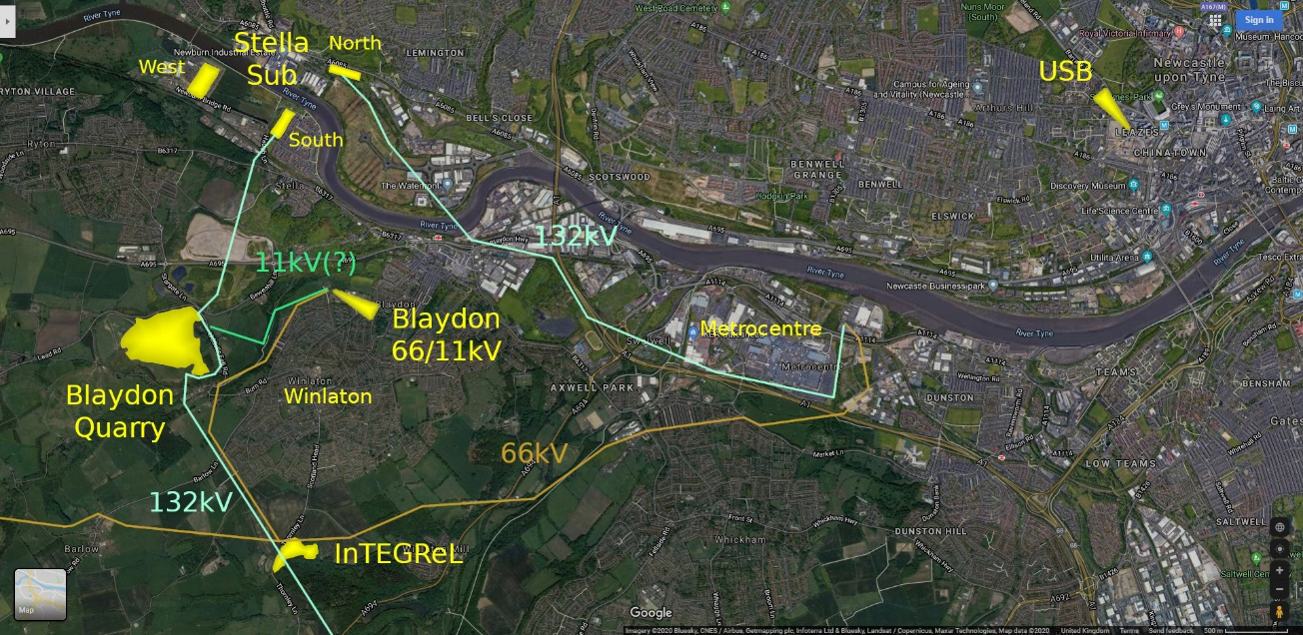

Figure 1 – InTEGReL location and electrical connections[2]

Figure 2 shows a schematic diagram of the case study integrated gas and electrical networks. The electrical network section is a diagrammatic representation of the extents of the Stella substation network[3]. The gas network used in the case study is a 39barg local transmission system main supplied from the gas transmission grid in the north at Saltwick in Northumberland, and in the south at Bishop Auckland in County Durham. The Low Thornley site is an important nexus which connects this pipe to a 19barg local transmission main supplying offtake sites across the country to the Cumbrian coast near Workington[4].

The gas and electrical networks are coupled using two proposed devices: a power-to-gas electrolyser, and a CHP plant. The two devices are connected to the gas network at the Low Thornley connection point and to the electrical network at the dual 66kV Dunston-Blaydon-Coalburns tee point 1 and 2 respectively. These connection points can be seen on the network schematic in Figure 2.

## Case Study Area Network Models

### Solution Environment

Analysis of the NoT model is performed using code written using MATLAB scientific analysis software. The overall structure of the solution environment is shown in Figure 3. The network models are defined external to the MATLAB software; the topology, physical properties and gas material properties of the gas network are defined in an Excel definition file, while the electrical network topology, physical properties and components are specified in in a Matpower case file (MATLAB .m format). The coupling components (described above) are specified in an Excel file as an efficiency value and a from-to pairing of nodes / buses from the respective gas / electrical networks.

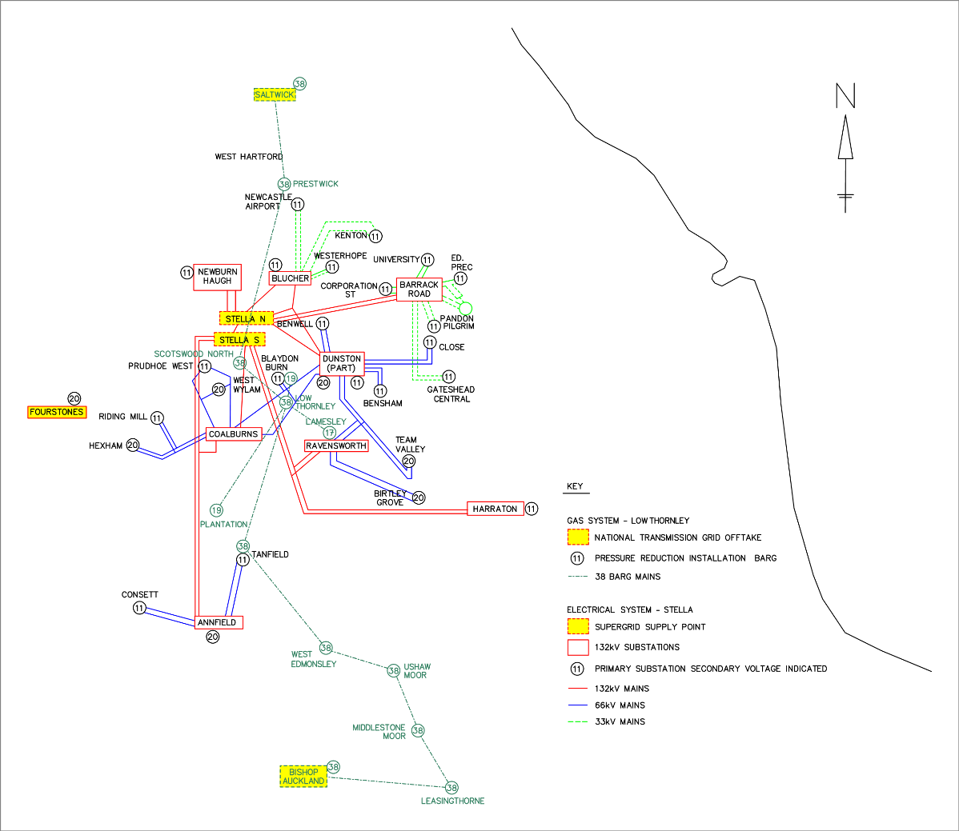

Figure 2 - Integrated gas and electrical network schematic diagram

Having read and created appropriate data structures, and resolved load balancing between the two networks, the network power flows, voltages and pressures are found using Matpower in the electrical case, and a Newton-Raphson solver developed within Newcastle University’s power systems group for the gas case[5]. A full description of the method is presented in Appendix A. Resultsl use through MATLAB .mat files (HDF5 format).

Visualisation is performed external to the MATLAB environment.

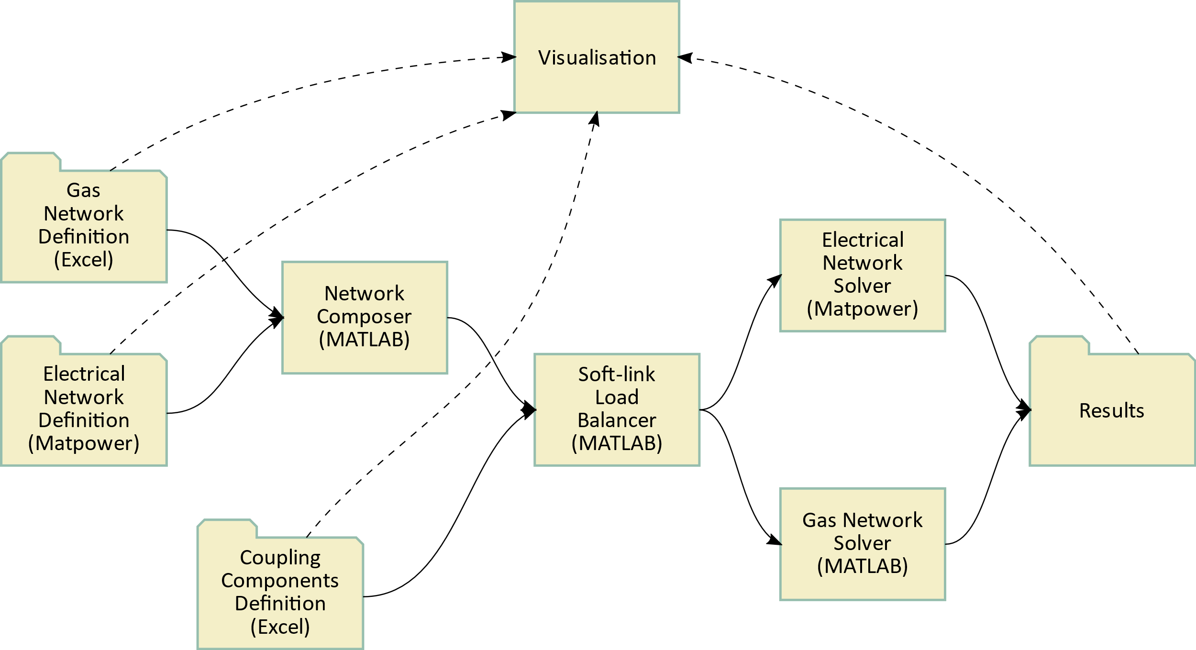

Figure 3 - Overall model scheme

### Visualisation

The visualisation infrastructure implements the Model, View, Controller (MVC) design pattern, which separates data (Model), user interface (View) and business logic (Controller). It is worth mentioning that the “Model” referred to in MVC is not the MatLab model referred to in other parts of this document. Therefore, to avoid confusion, this section will refer to the MatLab model as the “MatLab model” while “Model” (we will use capitalisation) will refer to the component of the MVC design pattern.

The diagram below shows the infrastructure which is implemented on an Azure Virtual Machine (i.e. a computer in the Microsoft Cloud). The Control and View components run inside Docker containers. Because the data used and produced by the MatLab model is of low volume and in CSV and JSON format, which are all plain ASCII files, there is no need for a database and the files are stored on the filesystem of the hosting server.

To avoid licensing issues the MatLab model needs to be compiled before it is included in the Docker image and deployed as a Docker container that hosts the MatLab model in an Ubuntu Linux environment. A REST API is being developed in Java (using a Spring framework) that allows the model to be controlled (e.g. setting parameters, stopping and starting) from outside the container.

The View component is a Docker container, based on a Node:12 image running nginx for serving a web-based client to visualise the data obtained via the Controller component’s API interface. There are three modules in the View component, a dashboard for controlling the MatLab model, a module that visualises the MatLab model output and a third potential module for data analysis via Jupyter Notebooks.

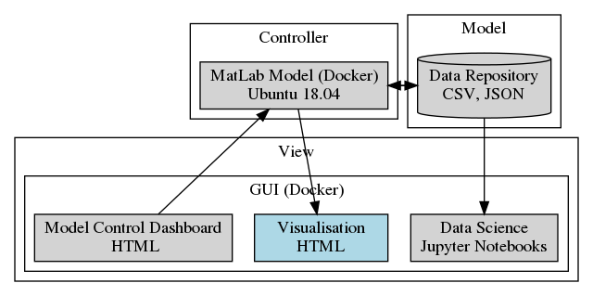

### Model Definitions

The original electrical network model is in the form of a 182-busbar IPSA[6] model definition supplied and validated by Northern Powergrid. This model has been converted to a Matpower equivalent by exporting in PSS/E format from IPSA and subsequently importing to Matpower[7]. The overall region contained in this model has already been seen in Figure 2.

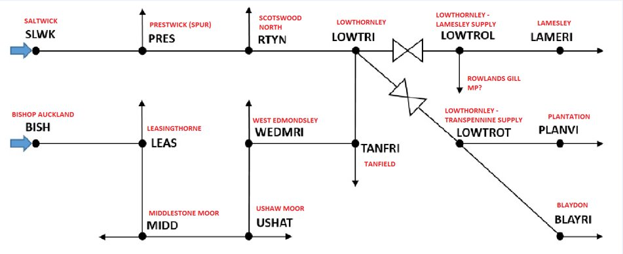

Figure 4 - Gas network connectivity graph

The gas network model was provided by Northern Gas Networks as a 15-node connection graph along with inter-nodal pipe distances and diameters, and assumed roughness factors. The connectivity graph is shown in Figure 4.

### Customer-Level Demand Data

An initial test data sample is provided with the model to permit generation of example results for testing and verification purposes, and for the development of emulator models. The network end points are subject to loads which are defined as follows.

Table 1 - Part of electrical demand data (P values)



The electrical network loads are supplied in two Microsoft Excel format files, one containing true power P, and the other reactive power Q, for a series of named busbars. These names correspond exactly to those supplied in the network model and are the same in both P&Q files. A single full day’s worth of data consisting of 48 time steps from 00.00 to 23.30 contain the P&Q demands in MW and MVar, with positive values representing power drawn from the network. There are no missing values. The exact day that the data are from is unknown. The data are supplied by Northern Powergrid.

It is not essential that a given busbar has both P&Q values defined. A busbar load definition with values in one file (P or Q) but missing in the other is treated as having values of zero for the absent P or Q specification. Similarly, missing values would be read as zero.

The gas network loads are supplied in a single Excel format file. The nodal points are in the same order as the order of nodes defined in the network and are thus indexed by column number rather than name. The file contains one day’s worth of gas demand in k m3 / hr (thousands of cubic metres per hour), and reference pressures in barg (gauge bar) for network infeed nodes (1 and 2). The time period of the data is from 06.00 to 06.00 (inclusive). In order to match this day to the electrical data, the second value at 06.00 was removed and the 00.00 to 05.00 period moved to before the 06.00 reading. Thus the load data is a semi-synthetic series produced from real data. Half-hourly values are created by linearly interpolating within the model code, creating 48 half-hourly values to match the electrical data’s sampling rate.

The exact day represented by the data is unknown but it is from a peak demand day in 2019. The data are supplied by Northern Gas Networks.

Table 2 - Gas demand data



## Sources of Uncertainty

### Background

This section describes the five general areas of uncertainty that have been identified in the North of Tyne (NoT) integrated energy network. Each area of uncertainty is explored herein under these subject areas: a description of the uncertainty and why it is important; whether it is proposed to deal with the uncertainty within the NoT project; how the uncertainty can be handled. These sources of uncertainty were explored and elaborated in a series of meetings between the Newcastle and Durham NoT project teams between 28/10/2019 and 14/01/2020.

It is proposed that uncertainty will be included in the project’s integrated network model using an emulator approach. An input / output emulator model can be constructed from the full physical model by evaluating the model output at judiciously selected points in the input variable space. The emulator model is subsequently used to estimate the output of the emulated system along with an uncertainty estimate of that output, for any valid input to the model.

### System Parameters

***Description***

In the proposed modelled NoT integrated energy system, integration is achieved by strategically coupling the electricity and gas networks using energy conversion devices. Two are devices used in the network: a power-to-gas plant (electrolyser); and a combined-heat-and-power unit (CHP) which produces electricity from gas. The devices are characterised by an efficiency performance curve which shows the energy conversion efficiency as a function of power output. However, such devices commonly operate at a limited range of set-points and can therefore be realistically characterised using point estimates of efficiency at the operating set-points.

There are many other parameters in the network that contain uncertainty. Material properties, efficiencies of devices (valves, transformers, etc), pipe roughnesses and diameters, network branch lengths, gas calorific value, and so on, are all estimated. Quantification of the uncertainties in these elements would allow the general network uncertainty to be estimated.

***Uncertainty***

The conversion efficiency of the plant is given as a “typical” point estimate and usually without reference to the likely uncertainty in that estimate.

The selection of a “typical” point estimate efficiency is done as a best guess. This could be improved by studying a range of similar conversion devices and constructing a model which related efficiency to plant size, age, cost and so on. From this a more informed “typical” plant efficiency value could be selected based on the expected purpose of the conversion plant.

***NoT Project Scope***

We will investigate the effect on the system of uncertainty in the efficiency of the energy conversion devices. It can be shown that the overall energy consumption of the system and hence carbon cost is linearly dependent on the plant efficiencies, which is not a problem which needs further study. Other more complicated functions of the efficiencies involving measurements on the network such as supply security, and optimal power flow studies, will therefore be needed.

We will not study the effect of general network parametric uncertainty in the NoT project, with the exception of the effect of gas composition. We will also not pursue the construction of an energy conversion plant model.

### Load and Generation Data

***Description***

The NoT network model terminal nodes are at 11kV (electrical network) and 38/19/17barg (gas network). The lower pressure and voltage networks supplying consumers and connected to these terminal points are therefore aggregated into single point estimates of load, with data used in simulations typically being real demand collected from network monitoring systems (SCADA).

***Uncertainty***

Actual demand on low-potential networks are a function of several parameters: geography; scale (number of consumers); load pattern (e.g. residential, industrial, commercial, public); load pattern mix; distributed energy mix and type. When classifying demand on low-potential networks, particularly when forecasting many years into the future, a great deal of uncertainty in each of these parameters is to be expected.

***NoT Project Scope***

Model simulation will be conducted using actual data provided by the network operators.

### Environmental Effects

***Description***

The environment has a recognisable effect on energy consumption. Ambient temperature in particular affects heat – and thus, at least in the NoT network region, gas consumption – and must be accounted for in modelling demand. Ambient temperature also affects electricity consumption, although this is much less pronounced than its effect on gas consumption. However, electricity consumption is strongly correlated with daylight duration and strength (i.e. month). Renewable energy production is obviously correlated with the availability of the resource that produces the energy.

***Uncertainty***

As the environmental dependence of both gas and electricity demand occurs “outside” of the integrated network, the uncertainty in network loads caused by the environment will be considered as an external uncertainty and used to adjust the loads themselves before they are used as an input to an emulator.

***NoT Project Scope***

A method using *degree days* will be used to create a model for the temperature correction for load.

No method for electricity correction for daylight has been defined yet.

### Time-Varying Parameters

***Description***

For the NoT project this primarily refers to how the energy conversion efficiency of a storage unit (electric battery) degrades over time.

## Considering the relationship between the heat demand and ambient temperature

### Method 1: Calculation of heat demand profile using ‘Heating Degree Days’ method

**From** [**www.degreedays.net**](http://www.degreedays.net)

The Heating Degree Days (HDD) method calculates the heat demand profile of a building based on the ambient temperature profile. In this method, if the ambient temperature is less than a base temperature, then the building would require an injection of heating energy to bring the temperature of the inside of building back to the comfort zone.

In order to obtain the heat demand profile of a standard building, follow these steps:

1. Go to the website below, which contains a comprehensive history of the ambient temperature in any location in the world and generates the HDD profile accordingly:

<https://www.degreedays.net/#generate>

1. Put the desired location in the ‘Station Search’ box (Figure 5).
2. Select the ambient base temperature in the ‘Base temperature’ box (Figure 5). In the UK the base temperature is normally considered 15.5 °C.

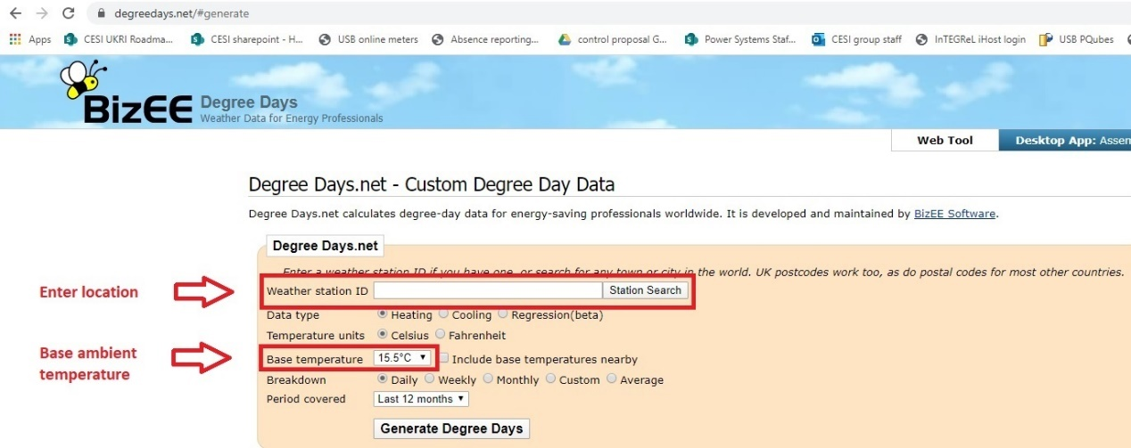

Figure 5 - Inputs of degreedays.net website

1. Hit the ‘Generate Degree Days’ button and download the HDD csv file once generated.
2. Copy and paste the HDD date and value profiles from the generated csv file in the cells A16 and B16, respectively, of the attached excel file template prepared for this purpose.
3. Adjust the value of the total HDD in cell B9 (the cell value highlighted in red in the formula written for this cell, i.e. SUM(B16:B390)) according to the number of the last cell for your analysis.

Once the above steps are followed, the excel file computes the following parameters and ***average daily*** profiles automatically:

* Total annual space heating demand of a standard building (cell B10) is calculated by multiplying the area (90 m2 [1]) and nominal space heating demand (129 kWh/m2/year (Ofgem-Medium) from Fig. 7 of [2]) of the building. Total annual space heating demand is 80% of the total annual heat demand of the building [3].
* Total annual domestic hot water (DHW) demand of the building (cell B11) is computed based on the fact that DHW is 17% of the total heat demand of the building [3].
* Total annual cooking demand of the building (cell B12) is calculated based on the fact that cooking demand is 3% of the total heat demand of the building [3].
* Each time step represents ***an average daily*** value for each day. In each time step:
  + The space heating demand (e.g. cell C16) is calculated by multiplying the value of the total annual space heating demand (already calculated in cell B10) by the value of HDD of this time step (e.g. cell B16) and dividing by the total HDD (already calculated in cell B9). The space heating demand is 80% of the total heat demand.
  + The DHW demand is 17% of the total heat demand (e.g. cell D16).
  + The cooking demand is 3% of the total heat demand (e.g. cell E16).
  + The total heat demand is the sum of space heating, DHW and cooking demands (e.g. cell F16).

### Method 2: Using the CREST demand model

**From:** [**https://www.lboro.ac.uk/research/crest/demand-model/**](https://www.lboro.ac.uk/research/crest/demand-model/)

The second method is to use the CREST demand model. It is a high-resolution stochastic model of domestic thermal and electricity demand. The model produces one-minute resolution demand data, disaggregated by end-use, using a bottom-up modelling approach based on patterns of active occupancy and daily activity profiles derived from time-use survey data. The model includes a representation of electrical demand and generation (appliances, lighting, and photovoltaics), resident occupancy, solar thermal collector, and thermal models including a low-order building thermal model, domestic hot water consumption, thermostat and timer controls and gas boilers.

The model has been validated and can be used to simulate demand of aggregations of dwellings such that dwelling diversity is duly represented, and end-use demand appropriately correlated. The bottom-up development of the model allows changes in appliances and their usage patterns to be represented, allowing quantification of the impact of changes in technology, for example the introduction of more efficient technologies, the electrification of heat, and the impact of demand response, in terms of changes in the timing of occupant activities.

The model has been developed primarily for low-voltage network analysis and the model’s ability to account for demand diversity is of critical importance for this application. The model, however, can also serve as a basis for modelling domestic energy demands within the broader field of urban energy systems analysis.

The model is an open-source development in Excel VBA and is freely available to download for users to configure and extend, or to incorporate into other models.

From Figure 6, it can be seen that the thermal demand model has the following inputs: control heating setting, the output of temperature model, the output of occupancy model, and the output of hot water demand model. The output of the thermal demand model is the dwelling gas demand. It is believed that for the NoT project this model will be more helpful for uncertainty integration as each of the inputs of thermal demand model is uncertain parameter.

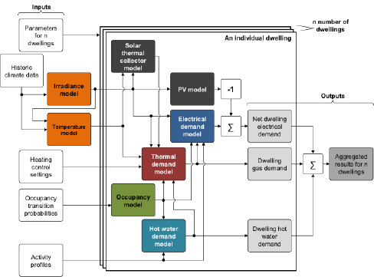

Figure 6 - High-level architecture of the CREST demand model

### References

[1] Office for National Statistics, House prices: how much does one square metre cost in your area?, 2017. https://www.ons.gov.uk/peoplepopulationandcommunity/housing/articles/housepriceshowmuchdoesonesquaremetrecostinyourarea/2017-10-11 <accessed 21.1.2020>.

[2] Royapoor M, Du H, Wade N, Goldstein M, Roskilly T, Taylor P, Walker S, 2019. 'Carbon mitigation unit costs of building retrofits and the scope for carbon tax, a case study'. Energy & Buildings 203 (2019) 109415.

[3] I.C. Jason Palmer, United Kingdom Housing Energy Fact File, Department of Energy & Climate Change, London, 2013 Editor.

[4] Eoghan McKenna and Murray Thomson. 2016. High-resolution stochastic integrated thermal-electrical domestic demand model. Applied Energy, 165:445. <http://dx.doi.org/10.1016/j.apenergy.2015.12.089>

[5] <https://www.lboro.ac.uk/research/crest/demand-model/>

## Storage modelling in the North of Tyne Case Study Model

### Current storage model in Operational Model 1

Operational Model 1 is the general precursor to the specific implementation of the North of Tyne case study network. The following storage types are currently modelled in operational model 1.

**Battery energy storage system (BESS) in the electricity network**

BESS is modelled as a load (at the time of charging) and generation (at the time of discharging). It is assumed that there is a simple energy management system where the storage is charged if there is a surplus of renewable generation in the electricity network and the State-of-Charge (SoC) of the BESS is within the range [0%-90%]. If the surplus energy makes the SoC higher than 90%, only part of surplus energy will be used to charge the BESS. The BESS will be discharged when the available renewable generation is not sufficient to meet the electric load and the SoC is higher than 20%. It is also assumed the State of Health (SoH) of the BESS is 100%, meaning the performance of it is not degraded over time.

**Gas storage (GS) in the gas network**

The GS in the gas network is modelled together with a power-to-gas (P2G) device. This means that the output of the P2G charges the GS. It is assumed any surplus of renewable energy from the electricity network is converted into natural gas via P2G and stored in the GS. The GS is assumed to be perfect and there is no leakage from it, meaning all the gas in the GS can be discharged and used.

### Integration of battery degradation in Operational Model 1

#### Model of battery degradation

Figure 7 shows the relationship between the efficiency, the SoC and the power inflow/outflow from the BESS which is composed of a set of lithium-ion batteries and a power converter. The efficiency considers the losses of the batteries and the converter.

Figure 8 depicts the relationship between the capacity loss and the SoH and the SoC, for the same aforementioned BESS.

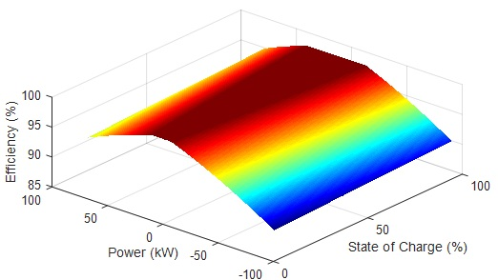

*Figure 7 - The efficiency of BESS as a function of SoC (%) and power inflow/outflow from the BESS*

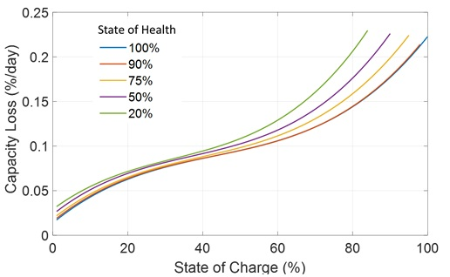

Figure 8 - The relationship between the capacity loss (%) and the SoC(%) and SoH (%)

It is important to mention that the two relationships shown in Figure 7 and Figure 8 are formulated as MATLAB functions.

#### How to integrate the battery degradation in Operational Model 1

Degradation of the BESS in the electricity network is not currently considered in Operational Model 1. However, it is possible to improve the existing model and consider degradation of the BESS and the BESS efficiency. Figure 9 shows the block diagram showing the inputs/outputs of the functions represented in Figure 7 and Figure 8.

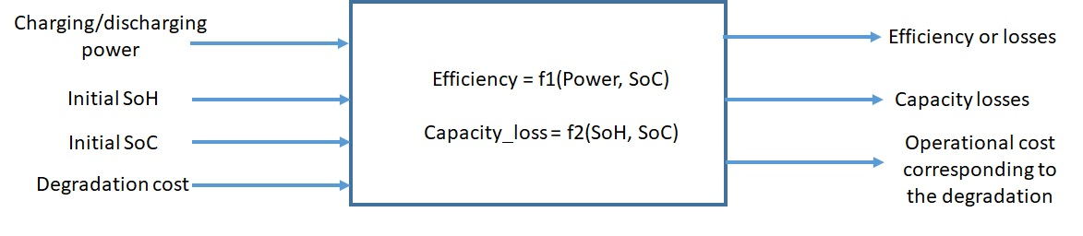

Figure 9 - Block diagram showing the inputs/outputs of the functions represented in Figure 7 and Figure 8

The relationship of efficiency can be considered in Operational Model 1 as follows: the charging and discharging power set-points will be calculated by the energy management system according to the amount of surplus renewable energy and the current (or initial) SoC as explained before. Then, the efficiency will be calculated, and the energy charged into the BESS or discharged from the BESS will be calculated. In addition, the SoC of the BESS can also be updated accordingly.

The current (or initial) SoC and the current (or initial) SoH will be used to calculate the capacity losses and then the operational cost corresponding to the degradation. Then, this cost can be added to the operational costs of the integrated electrical and gas networks.

# Appendix A – Mathematical models and solving algorithms

## Framework overview

A framework has been developed for gas and power flow analysis of integrated power and gas networks at both transmission and distribution levels (Figure 10). In both levels some coupling components have been considered to allow bi-directional flow of energy between the networks. These components are gas turbines and power-to-gas devices in the transmission network, and CHP, electrolysers and power-to-gas units at distribution level. Integrated (unified system) power flow analysis has been implemented in both levels separate from each other. A set of nonlinear equations consisting of mismatches of power flow at the buses of the electricity network and mismatches of flow at the nodes of the gas network has been formed. Power flow analysis has been performed by solving the set of equations. The set has been solved for the distribution and transmission levels using the Newton-Raphson method by forming the Jacobian.

The values of the loads are input to the distribution level model and the values of the supplied gas from the gas source and power from the slack bus are calculated. Afterwards, these values are input to the transmission level model as the loads for gas and power, and then the values of supplied power and gas from the sources of power and gas in the transmission level are calculated. Nevertheless, if either of the transmission level networks require change in the values of supply to the distribution level those can be accommodated by the distribution level through the energy flow from the coupling components.

In the North of Tyne project, only a distribution level analysis of the regional networks is carried out.

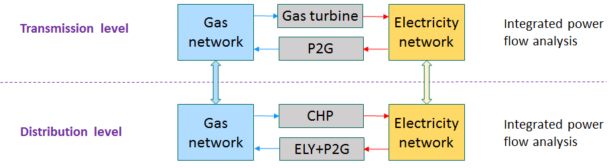

Figure 10 - Developed framework for the gas and power flow analysis

The overall algorithm of the model implemented and developed in MATLAB to simulate operation of integrated gas and electricity networks at distribution and transmission levels is shown in **Error! Reference source not found.**. At each level, the equations for the balance of gas flow at all the nodes of the network are formed. Then, the flows in the branches are written in terms of the pressures at the two ends of the branches using the gas flow equation. Therefore, the equations of flow balance will be transformed into equations in terms of the pressures of the nodes of the gas network. At the transmission level, the power consumption of compressors is also considered. The power consumption of a compressor is a function of the pressure at its inlet and outlet, and the flow through it. In the electric network, the power balance equations are also written as functions of the voltage (magnitude and angle) of the buses. The coupling components are also considered into the set of equations for balance of gas and electricity power flow. The number of equations is equal to the sum of the number of the unknown pressure values, the number of compressors, and the number of unknown parameters of bus voltages, i.e. voltage magnitude and voltage angle. The set of nonlinear equations are solved using a Newton-Raphson method and the values of the unknown variables mentioned above are found. Once the values of nodal pressures and the values of bus voltages are obtained the values of the flows of the gas pipelines and the power flow through electricity branches are calculated using the gas and power flow equations.

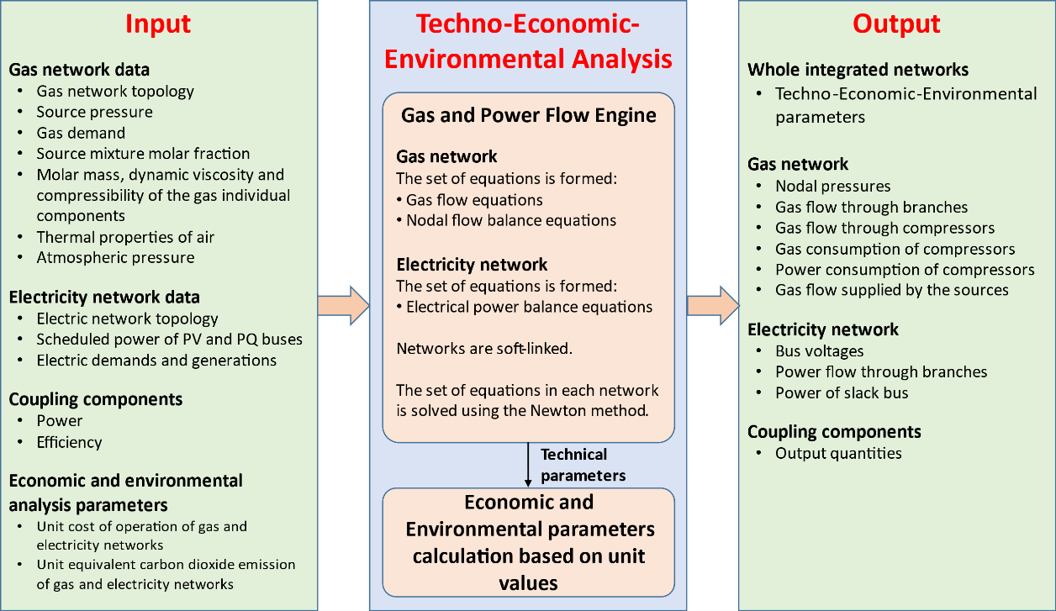

Figure 11 - Overall schematic of the implementation algorithm

## Mathematical model of the gas network

The gas network model includes the matrix representations of natural gas networks, the generalised gas flow equation used for calculating the flow through the distribution networks, calculation of the flow of the branches, Weymouth flow equation used for calculating the flow through the transmission networks, pressure regulator modelling, compressor horsepower equation, and conservation of mass flow equation.

In this section the following physical properties are used to develop a generalised equation for the flow of a gas mixture. A gas mixture is comprised of one or more pure gases. Physical properties are referenced at standard temperature and pressure (STP).

#### Constants

|  |  |  |
| --- | --- | --- |
|  | $$T_{n}$$ | Standard temperature |
|  | $$p_{n}$$ | Standard pressure |
|  | $$R_{air}$$ | Gas constant for air |
|  | $$ρ_{air}$$ | Density of air at STP |
|  | $$z_{air}$$ | Air compressibility factor at STP |
|  | $$M_{air}$$ | Molar mass of air |

#### Gas properties

|  |  |  |
| --- | --- | --- |
|  | $$N_{c}$$ | Number of gases in mixture |
|  | $$y_{i}$$ | Molar fraction of gas $i$ in the mixture |
|  | $$M_{i}$$ | Molar mass of gas $i$ in the mixture |
|  | $$μ_{i}$$ | Dynamic viscosity of gas $i$ in the mixture |
|  | $$c_{i}$$ | Summation factor for gas $i$ (on page 11 of ISO 6976:1995[8]) |
|  |  | Gross calorific value of gas $i$ in the mixture (MJ/m3) |
|  |  | Gross calorific value of natural gas (MJ/m3) |
|  |  | Absolute gas pressure at the sending end of the pipe |
|  | $$p_{2}, p_{j}$$ | Absolute gas pressure at the receiving end of the pipe |
|  | $$T$$ | Average gas temperature |
|  | $$S_{mix}$$ | Gas mixture specific gravity |
|  | $$z_{mix}$$ | Gas mixture compressibility factor |
|  | $$ρ_{mix}$$ | Gas mixture density |
|  | $$μ_{mix}$$ | Gas mixture dynamic viscosity |
|  | $$S_{g}$$ | Gas gravity |
|  | $$z_{g}$$ | Average gas compressibility factor |

#### Geometric properties

|  |  |  |
| --- | --- | --- |
|  | $$D$$ | Pipe diameter |
|  | $$L$$ | Length of the pipe |
|  | $$A$$ | Pipe cross-sectional area |
|  | $$ϵ$$ | Roughness of the internal surface of the pipe |

#### Mechanical properties of the flow

|  |  |  |
| --- | --- | --- |
|  | $$q$$ | Gas volumetric flow rate at STP |
|  | $$v$$ | Mean velocity of the gas flow |
|  | $$f$$ | Flow friction factor |
|  | $$Re$$ | Reynolds number |
|  | $$S_{ij}$$ | Flow direction, where $S_{ij}=1$ if $p_{i}>p_{j}$, and $S_{ij}=-1$ if $p_{i}<p_{j}$ |
|  | $$η_{pk}$$ | Pipeline efficiency |

### Matrix representations of networks

The architecture of a network can be described by the branch-nodal incidence matrix [9] [10]. This matrix is rectangular, with the number of rows equal to the number of nodes (including reference nodes), and the number of columns equal to the number of pipelines in the network. The element $A_{ij}$ of the matrix $A$ corresponds to node 𝑖 and branch *j*, and is defined as: $A_{ij}=1$, if pipeline branch *j* enters node 𝑖, $A_{ij}=-1$ if pipeline branch *j* leaves node 𝑖, and $A_{ij}=0$ if pipeline branch *j* is not connected to node 𝑖. Other matrices will be introduced later to describe the architecture of a gas network when compressors are present in the network.

### The generalised gas flow equation

The generalised gas flow equation used for the calculation of gas flow in the pipe branch based on the pressures of the two ends of the branch, neglecting the elevation difference, is[11]:

|  |  |  |
| --- | --- | --- |
|  |  | (1) |

The friction factor *f* is calculated based on the value of the gas flow Reynolds number, Re:

|  |  |  |
| --- | --- | --- |
|  | $$Re=\frac{D v ρ_{mix}}{μ_{mix}}$$ | (2) |

where the mean velocity of the gas through the pipe cross-sectional area $A={πD^{2}}/4$

|  |  |  |
| --- | --- | --- |
|  | $$v= \frac{q}{A}=\frac{q}{\left(π/4\right)D^{2}}$$ | (3) |

The values of the density of the gas mixture, $ρ_{mix}$, the specific gravity, $S_{mix}$, the gas mixture compressibility factor, $z_{mix}$, and the gas dynamic viscosity, $μ_{mix}$, are calculated using the following expressions:

|  |  |  |
| --- | --- | --- |
|  | $$ρ_{mix}=S_{mix} ρ_{air}$$ | (4) |
|  | $$S_{mix}= \frac{z_{air}\sum_{i=1}^{N_{c}}{\left(y_{i} M_{i}\right)}}{M_{air} z_{mix}}$$ | (5) |
|  | $$z_{mix}=1- {\left(\sum_{i=1}^{N_{c}}{\left(y_{i} c_{i}\right)}\right)}^{2}$$ | (6) |
|  | $$μ_{mix}= \frac{\sum_{i=1}^{N_{c}}{\left(y_{i} μ_{i} M_{i}^{0.5}\right)}}{\sum_{i=1}^{N_{c}}{\left(y_{i} M_{i}^{0.5}\right)}}$$ | (7) |

Making appropriate substitutions and simplifying, Reynolds number is then given by:

|  |  |  |
| --- | --- | --- |
|  | $$Re=\frac{ρ_{air}}{\left(π/4\right)} \frac{q S_{mix}}{D} \frac{\sum_{i=1}^{N_{c}}{\left(y_{i} M_{i}^{0.5}\right)}}{\sum_{i=1}^{N_{c}}{\left(y_{i} μ_{i} M_{i}^{0.5}\right)}}$$ | (8) |

The friction factor is calculated depending on the flow regime, which is indicated by the calculated Reynolds number:

* Laminar flow ($Re<2300$):

|  |  |  |
| --- | --- | --- |
|  | $$f=\frac{64}{Re}$$ | (9) |

* Turbulent flow ($Re>4000$), which frequently happens in gas networks, in which the friction factor can be calculated using Colebrook’s equation, an empirical relationship based on Moody’s diagram of friction factor as a function of Reynolds number:

|  |  |  |
| --- | --- | --- |
|  | $$\frac{1}{\sqrt{f}}=-2\log_{10}\left(\frac{ϵ/D}{3.7}+\frac{2.51}{Re \sqrt{f}}\right)$$ | (10) |

### Calculation of branch flow

Figure 12 shows a flowchart demonstrating the logic in calculating the flow in the branches. The solution process starts with a guess of the values of the nodal pressures. These values are corrected in each iteration until the amount of correction is small enough and the set of non-linear equations converges to the final solution. In other words, the values of nodal pressures are known in each iteration. Therefore, the next step of the problem is to calculate the values of flows of the branches given the values of the nodal pressures of the two ends of the pipe.

It will be noticed that calculation of the gas flow rate in Equation (1) requires the value of the friction factor of the flow. However, as can be observed from either of the Equations (9) or (10), the calculation of the friction factor depends on the value of the Reynolds number, which itself depends on the value of the flow rate according to Equation (8). Therefore, the value of the flow must be calculated iteratively. Once the values of the nodal pressures of the two ends of the pipe are known, a value for the flow in the branch is guessed. Then, the value of the Reynolds number is calculated using Equation (8). Afterwards, based on the regime of the flow the value of the friction factor, $f$, is computed from Equations (9) or (10). Subsequently, the new value of the flow of the pipe is calculated using Equation (1). If the difference between the new value and the old (guess) value is acceptable the iteration halts and the solution is found. Otherwise the process is repeated with the new value of the flow until the solution converged. This process is depicted in Figure 12.

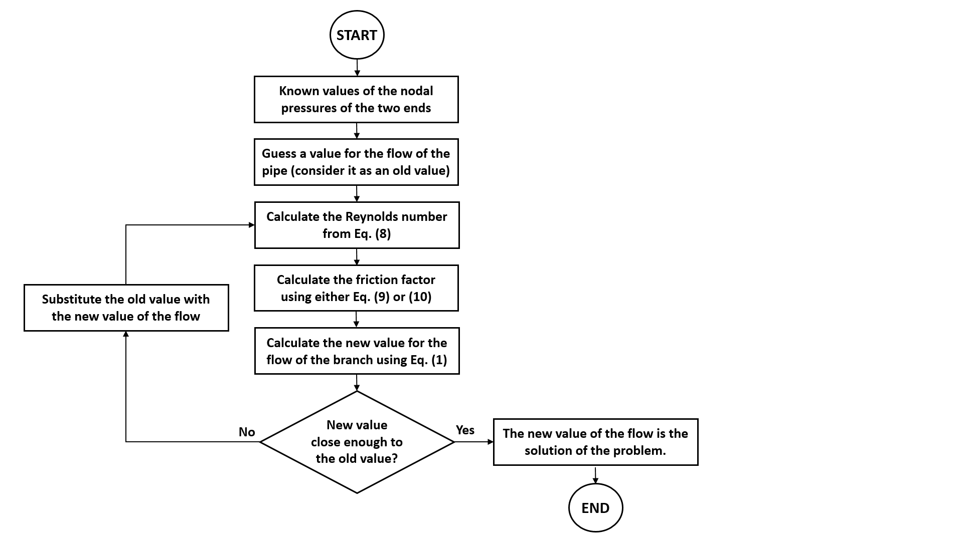

Figure 12 - Flowchart for pipe flow calculation

### Weymouth Equation

Another flow equation used for high pressure networks, such as transmission networks, is the Weymouth equation. The main assumption in the derivation of Weymouth equation is that the friction factor is only dependent on the diameter of the pipe, which is reasonable for the fully turbulent flow regime. Consequently, in fully turbulent flow conditions in high pressure transmission networks, the friction factor is calculated as

|  |  |  |
| --- | --- | --- |
|  | $$f=\frac{0.032}{D^{1/3}}$$ | (11) |

Then the flow equation becomes

|  |  |  |
| --- | --- | --- |
|  | $$q=S_{ij} M_{k}\sqrt{S_{ij}\left(p_{i}^{2}-p_{j}^{2}\right)}$$ | (12) |
|  | $$M_{k}=η_{pk} \frac{18.062 T_{n}D^{8/3}}{P_{n} \sqrt{S_{g} L T Z_{g}}}$$ | (13) |

As indicated in Equation (12), the gas flow can be determined once $p_{i}$ and $p_{j}$ are known for given conditions. Equation (12), which is known as the Weymouth flow equation, is most satisfactory for large diameter ( $≥10$ inches) lines under high pressures. The developed framework uses this equation to calculate the flow through the branches of transmission networks.

### Pressure regulator modelling

The output pressure of pressure regulators is regulated by the gas network operator. Therefore, the gas network downstream of a pressure regulator itself has been treated as a gas network with a source pressure equal to the output pressure of the pressure regulator, which is known and kept fixed by the network operator.

### Compressor modelling

A key characteristic of the centrifugal compressor is the horsepower consumption, which is a function of the amount of gas that flows through the compressor and the relative boost ratio between the suction and the discharge pressures. The compressor horsepower (BHP) equation is given as:

|  |  |  |
| --- | --- | --- |
|  | $$BHP_{ij}=B_{k}q_{k}\left[{\left(\frac{p_{j}}{p_{i}}\right)}^{z_{ki}\left(\frac{α-1}{α}\right)}-1\right]$$ | (14) |
|  | $$B_{k}=\frac{3554.58 T_{ki}}{η_{k}}\left(\frac{α}{α-1}\right)$$ |  |

where

|  |  |  |
| --- | --- | --- |
|  | $$q_{k}$$ | Flow rate through compressor |
|  | $$p_{i}$$ | Compressor suction pressure |
|  | $$p_{j}$$ | Compressor discharge pressure |
|  | $$z_{ki}$$ | Gas compressibility factor at compressor inlet |
|  | $$T_{ki}$$ | Compressor suction temperature |
|  | $$α$$ | Specific heats ratio |
|  | $$η_{k}$$ | Compressor efficiency |

### Conservation of mass and energy flows

The mass flow balance equation at each node can be written in matrix form as [4]

|  |  |  |
| --- | --- | --- |
|  | $$Aq_{p}+Uq_{c}+W-T_{τ}=0$$ | (15) |

where

|  |  |  |
| --- | --- | --- |
|  | $$q_{p}$$ | Vector of flow rate through pipelines |
|  | $$q_{e}$$ | Vector of flow rate through compressor |
|  | $$A$$ | Branch-nodal incidence matrix |
|  | $$W$$ | Vector of gas supply and demand at each node |
|  | $$T$$ | Matrix representing where gas is drawn to power the gas turbine of the compressor |
|  | $$τ$$ | Gas supplied to the gas turbine of the compressor |
|  | $$U$$ | Matrix describing the connection of compressors and nodes |

In addition to the matrix $A$, which represents the interconnection of pipelines and nodes, we define the matrix $U$, which describes the connection of compressors and nodes. In this matrix, the item $U_{ik}=+1$ if the $k$ th compressor has its outlet at node $i$, and $U_{ik}=-1$ if the $k$ th compressor has its inlet at node $i$; $U_{ik}=0$ otherwise. The vector of gas injections $W$ is obtained as

|  |  |  |
| --- | --- | --- |
|  | $$W=W_{S}-W_{L},$$ | (16) |

where

|  |  |  |
| --- | --- | --- |
|  | $$W_{S}$$ | A vector of gas supplies at each node |
|  | $$W_{L}$$ | A vector of gas demands at each node |

The matrix $T$ and the vector $τ$ represent where gas is withdrawn to power a gas turbine to operate the compressor. In the matrix $T,$ the item $T_{ik}$ is +1; if the kth compressor’s turbine gets gas from node $i$, and 0 otherwise. The gas supplied to the gas turbine of the compressor $k$ can be approximated using the analytical expression

|  |  |  |
| --- | --- | --- |
|  | $$τ=α_{k}+β_{k}{ BHP}_{k}+γ_{k}^{2}{ BHP}_{k}^{2},$$ | (17) |

where $α_{k}, β_{k}, γ_{k}$ are the compressor’s gas consumption coefficients.

Gas network loads are usually specified as a volumetric flow rate of natural gas, which consists of approximately 90% methane with the remaining 10% being composed of other alkanes and inert compounds such as nitrogen. The use of other gas compositions such as those using hydrogen or high methane concentrations require an adjustment to the gas load flow rates which conserves the energy in the flow, i.e.:

|  |  |  |
| --- | --- | --- |
|  | $$q_{ng}{ GCV}_{ng}= q_{mix} GCV_{mix}$$ | (18) |

Here, $q_{ng}$ is the natural gas equivalent load (flow) at a given node, ${GCV}_{ng}$ is the gross calorific value of a reference specification of natural gas, $q_{mix}$ is the adjusted load flow rate of the gas mix in the system, and $GCV_{mix}$ is the gross calorific value of the system gas mixture.

## Mathematical model of the electricity network

An alternating current (AC) power flow model is used to represent the electricity network. The steady state operation of a power system is formulated by stipulating that, at each system’s bus, the power injected by generators, the power demanded by loads, and powers exchanged through the transmission elements connected to the bus must add up to zero. This applies to both active and reactive powers. Consequently, the real and reactive power injections at bus $i$ need to satisfy the following equations:

|  |  |  |
| --- | --- | --- |
|  | $$P_{G_{i }}-P_{L_{i }}- P_{i}\left(V,θ\right)=0$$ | (19) |
|  | $$Q_{G_{i }}-Q_{L_{i }}- Q_{i}\left(V,θ\right)=0$$ | (20) |

The quantities in Equations (19) and (20) are defined as follows:

|  |  |  |
| --- | --- | --- |
|  | $$P_{G_{i }}$$ | Real power generation at bus $i$ |
|  | $$P_{L_{i }}$$ | Real power load at bus $i$ |
|  | $$Q_{G_{i }}$$ | Reactive power generation at bus $i$ |
|  | $$Q_{L_{i }}$$ | Reactive power load at bus $i$ |
|  | $$P_{i}$$ | Real power injection at bus $i$ |
|  | $$Q_{i}$$ | Reactive power injection at bus $i$ |
|  | $$V$$ | Bus voltage magnitude vector |
|  | $$θ$$ | Bus voltage angle vector. |

## Models for network coupling components

Interaction between the natural gas and electricity networks is provided by power-to-gas (P2G) units and generators driven by gas-fired turbines (i.e. gas turbines or CHP machines), both of which act as energy converters. This coupling is mathematically formulated in Equations (21) and (22).

|  |  |  |
| --- | --- | --- |
|  | $$q_{gen}= \frac{3600 P_{gen}}{η_{gen}*GCV_{mix}}$$ | (21) |
|  | $$q_{P2G}= \frac{3600 P_{P2G} η_{P2G}}{GCV_{mix}}$$ | (22) |

where

|  |  |  |
| --- | --- | --- |
|  | $$q_{gen}$$ | Gas flow supplied to the gas-fired turbines’ generator (m3/hr) |
|  |  | Generated real power (MW) |
|  | $$η_{gen}$$ | Generator efficiency |
|  | $$q_{P2G}$$ | Gas flow produced by the P2G unit (m3/hr) |
|  |  | Real power supplied to the P2G unit (MW) |
|  | $$η_{P2G}$$ | Efficiency of P2G unit |
|  | $$GCV_{mix}$$ | Gas mixture gross calorific value (MJ/m3) |

The gross calorific value of the gas mix is calculated as

|  |  |  |
| --- | --- | --- |
|  | $$GCV_{mix}= \sum_{i=1}^{N_{c}}{y_{i} {GCV}_{i}}$$ | (23) |

The relevant coupling components quantities are substituted into Equations (15), (16) and (19), where these components affect the quantities $W_{s}$, $W_{L}$, $P_{L}$ and $P_{G}$.

## Integrated gas and power flow solution

The integrated gas and electrical power flow formulation of the natural gas and electricity infrastructures is created by linking the infrastructure flow models through gas-fired power plants connected to gas pipelines, and power-to-gas units which use electrical energy to produce gas. The set of nonlinear equations that must be solved for the state of the variables in both infrastructures are those given in the previous sections. These equations are solved by applying a Newton-Raphson technique for each network in turn (the electrical network is solved using the Matpower electrical network solver) to provide an approximate solution to the total set of equality constraints. The Jacobian matrix used in Newton’s solver is given in Equation (24).

|  |  |  |
| --- | --- | --- |
|  |  | (24) |

In this expression, the number of equations is $NN-NS+NC+N_{coupling}+2 nnb$, which must equal the number of unknown decision variables where

|  |  |  |
| --- | --- | --- |
|  | $$NN$$ | The number of nodes in the gas network |
|  | $$NS$$ | The number of gas sources |
|  | $$NC$$ | The number of compressors |
|  | $$N_{coupling}$$ | The number of coupling components |
|  | $$nbb$$ | The number of buses in the electrical network |

The coupling components are incorporated into the integrated system as supply-following coverter elements defined by an efficiency value, with the supply energy flow being determined by operational and design policies. In this instance the term “supply” is as seen from the coupling component’s viewpoint. There are $N_{coupling}$ coupling components $κ$ in the integrated network, with the $n$ th such component being connected between node $i$ in network $x$, and node $j$ in network $y$. The general form of an energy efficiency converter of this type, where the energy flowing into network $x$ from network $y$ is given as the product of an effort ($e$) and flow ($f$) pair, is

|  |  |  |
| --- | --- | --- |
|  | $$e_{x} f_{x}=κ_{xy} e_{y} f_{y}$$ | (25) |

As the transformation element represents an energy efficiency, then $0≤κ_{xy}≤1$, $0≤κ_{yx}≤1$, and $κ_{xy}≠_{n}κ_{yx}$ (where $≠_{n}$ means “does not necessarily equal”). Additionally, one of $κ_{xy}$ or $κ_{xy}$ must exist or the idea of the coupling device is meaningless; but either may be undefined, indicating that energy conversion in that direction is not physically possible. A value of zero for either of the efficiency values means that that device converts no energy; this state may be set in the solver as a switch to simulate a non-operating or unavailable device.

# Appendix B - Heat Decarbonisation Scenario Descriptions

Authors: Sarah Sheehy, Robin Wardle, Haris Patsios, Laura Brown, Hamid Hosseini, Adib Allahham

EPSRC National Centre for Energy Systems Integration (CESI), Newcastle University

31st March 2020

## Introduction

The North of Tyne Combined Authority Energy Systems Integration project looks to examine the impact of heat decarbonisation on current network capacity. This research considers a near-term planning horizon (approximately 3-5 years ahead) during which we could see the increased uptake of readily available technologies, but where wide-scale deployment of emerging technologies is not possible.

This work therefore assumes that near-term decisions for heat decarbonisation will primarily consist of:

1. Demand reduction through improved insulation in domestic buildings
2. Electrification through the installation of domestic heat pumps

Decarbonisation was identified as a key driver for change for future development of the regional energy system in a recent study with North of Tyne Combines Authority stakeholders[12]. This research will therefore consider to what extent energy systems integration (ESI), through the coordinated operation of both electricity and gas networks, and the inclusion of network coupling technologies, reduces the cost and carbon emissions and improves the resilience of the distribution network when a proportion of heat demand is decarbonised.

## Scenarios

Considering the two key drivers for this research – heat decarbonisation and energy systems integration – there are four scenarios to consider:

* **1a: Business as Usual (BaU)**

Modelling the electricity and gas network infrastructure as they are now.

* **1b: BaU with Heat Decarbonisation**

Improved insulation and electrification of heat for domestic customers.

* **2a: Energy Systems Integration**

Modelling the integrated gas and electricity networks with coordinated operation. Underlying demand and generation remain the same, but ESI assets including a combined heat and power plant (CHP) and electrolyser connect the networks.

* **2b: ESI with Heat Decarbonisation**

Following the same insulation and electrification of heat decisions as in 1’, but now with the support of ESI as defined in 2.

Figure 13 illustrates these scenarios and drivers.

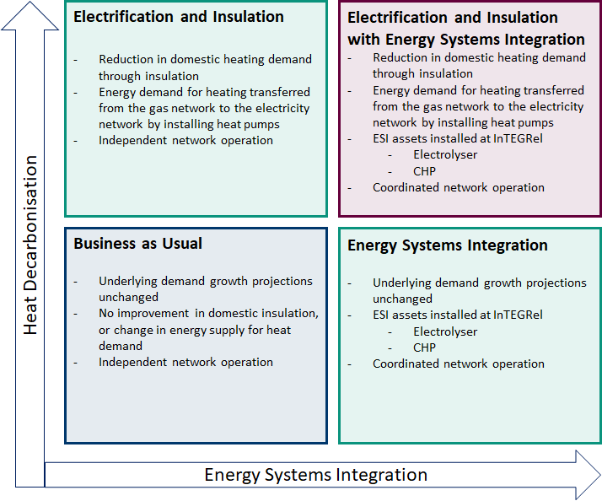

Figure 13 - Scenario Matrix: Heat Decarbonisation vs Energy System Integration

Table 3 summarises each scenario, describing the operating framework, inputs and outputs, and key assumptions.

*Table 3 - Scenario Descriptions and Key Assumptions*

|  |  |  |  |  |
| --- | --- | --- | --- | --- |
| **Scenario** | **Operating Framework** | **Inputs** | **Outputs** | **Key Assumptions** |
| **1a BaU** | - Distinct gas and electricity network operation  - No operational optimization in terms of cost or carbon emissions | - Distribution network topology for the gas and electricity networks  - Network parameters  - Electricity demand data for each node  - Gas demand for each node | - Cost of operation, carbon emissions, Constraints (by type and location, if any occur)  - Visualisations | - Gas and electricity demand profiles at the network nodes  - Demand growth |
| **1b BaU+HD** | - Distinct gas and electricity network operation  - No operational optimization in terms of cost or carbon emissions  - Assumption on how load profiles will change, either due to deployment of heat pumps, or through improved building insulation | - Number of domestic heat pumps installed  - Number, type, and location of properties with improved insulation  - Modified electricity demand (generated by process outline in XX)  - Modified gas demand | - Cost of operation, carbon emissions, Constraints (by type and location, if any occur) | - Gas and electricity demand profiles at the network nodes  - Demand growth  - Number of CHPs installed  - Type of buildings insulated  - How CHP installation and property insulation change demand profiles |
| **2a ESI** | - Coordinated gas and electricity network operation from InTEGRel  - Fixed sized ESI assets installed: X Combined Heat and Power (CHP) plant, and Y electrolyser  - Operation optimised for (least) cost (with carbon) | - Size of ESI assets | - Cost of operation, carbon emissions, Constraints (by type and location, if any occur) | - Gas and electricity demand profiles at the network nodes  - Demand growth  - Size of deployable CHP and Electrolyser  - Cost of carbon |
| **2b ESI+HD** | - Coordinated gas and electricity network operation  - Fixed size ESI assets installed: X Combined Heat and Power (CHP) plant, and Y electrolyser  - Same load profile as in 1’ for heat decarbonisation | - Coordinated operating strategy?  - Number of domestic heat pumps installed  - Number, type, and location of properties with improved insulation  - Modified electricity demand | - Cost of operation, carbon emissions, Constraints (by type and location, if any occur) | - Number of CHPs installed  - Type of buildings insulated, and resultant reduction in energy demand  - How CHP installation and property insulation change demand profiles  - Size of deployable CHP and Electrolyser |

## Region of interest

The North of Tyne Combined Authority (NoT CA) is comprised of the local authorities for Newcastle Upon Tyne, North Tyneside, and Northumberland. The NoT CA Energy Systems Integration project is investigating the region supplied by the gas and electricity networks shown on the map in Figure 14[13] as these are the sections of the gas and electricity networks where topology data is currently available. The case study region includes some of Newcastle and extends into Gateshead and County Durham but could be expanded to include additional networks across the NoT CA region in future.

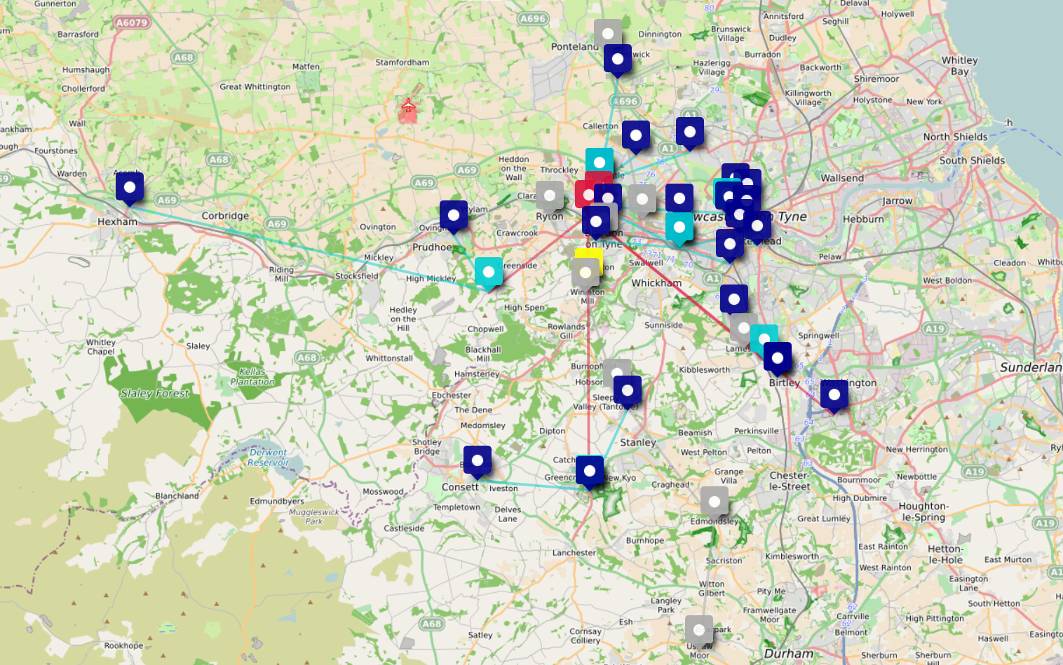

Figure 14 - Map of the Electricity and Gas Network Nodes (created with Umap for Open Street Maps)

|  |  |
| --- | --- |
| **Electricity and Gas Network Nodes - Key** | |
| **Electricity Network** | **Gas Network** |
| Grid Supply Points: Crimson  Bulk Supply Points: Turquoise  Primary Substations: Navy | Nodes/Governors: Grey  InTEGRel site: Yellow |

Note that the gas network extends beyond the map: North to Saltwick, and South to Bishop Auckland.

This area contains the site for the Integrated Transport Gas Electric Research Laboratory (InTEGReL) in Low Thornley, Gateshead, shown by the yellow marker in Figure 14. InTEGReL is planned to be the UK’s first multi-vector integrated energy systems research and demonstration facility investigating utility scale infrastructure, and joint operation between Northern Powergrid (electricity) and Northern Gas Networks (gas).

## Consumer demand data

The following section explores the available consumer demand data which are to be used as loads for the network models. Descriptions and definitions of the governing equations and parameters used in the system modelling are outlined in Appendix A, and the network topologies and location of network nodes are mapped in Figure 14.

There is significant uncertainty around the future growth of electricity and gas demand due to uncertainties in shape, magnitude, location, scale and future development/growth. However, current underlying consumer demand is also subject to uncertainty because of metering, geographic and social-demographic unknowns. These unknowns are examined in the following sections.

### Consumer demand data at network nodes

Table 4 shows the data sets that will be used to create the simulated network loading for the North of Tyne integrated energy network. Further elaboration of the composition of these data sets is given below.

Table 4 - Available gas and electricity network demand data

|  |  |
| --- | --- |
| **Gas Network** | **Electricity Network** |
| 5 “representative” days of demand data per node:   1. 1/20 peak demand 2. Average Winter 3. Cold Winter 4. Spring/Autumn 5. Warm Summer | Half-hourly time-series data for each network node from August-November 2017 (some data missing for some days in October). |
| This is *simulated* data from Northern Gas Network’s Graphical Falcon network model.  The exact geographic location of each node is unknown. Only network names that correspond to towns/villages are available. | This is *metered* data at the primary substation level (generally 11kV).  The exact geographic location (longitude, latitude) of each node is known. |

#### Gas network

Northern Gas Networks have produced simulated data of the hourly demand at each network node for a set of “representative” days, as given in Table 4. Publicly available datasets that will be drawn on to supplement these provided data are discussed in detail later in this section.

#### Electricity network

Northern Powergrid have provided a limited set of half-hourly metered data from 2017 for the primary substations on the study network (shown in turquoise in Figure 14). This data runs from August to November 2017 inclusive, and thus is unlikely to include the winter peak demand when the system will be particularly stressed. Also provided by the DNO is a set of structural data for the lower voltage network connected to each primary substation in the network. It is therefore reasonable to construct “representative” demand days for the electricity network that correspond to those available for the gas network, based on the additional data available.

### Additional electricity distribution network operator (DNO) data

Hierarchical data is available from the DNO that describes the structure of the lower voltage network (below 11kV), and how this connects to the primary substations (network nodes). Consumers connected to a primary substation are classified by type – domestic, or industrial and commercial (I&C) – and by typical *demand profile*. A demand profile is an estimate of the average half-hourly electricity consumption for a particular customer type. The data provided give, for each primary substation in the network: the total number of consumers connected through lower voltage networks to that primary substation; the number of each type and each demand profile within this consumer base; and the total annual energy consumption through that substation for the years 2017 and 2018. However, these data do not include metered half-hourly demand data for any part of the network.

Most domestic and smaller industrial and commercial consumers are either not metered, or they are metered on a half-hourly basis. Consumers with smart meters installed are metered at more precision, but a low roll-out of smart meters across the North-of-Tyne region means that such data is scant. Some large industrial customers are metered half-hourly, but this data is not readily available outside the DNO. Most network demand beyond the primary substation is therefore not known, and the half-hourly consumption of individual consumers is not visible.

Instead the DNO uses estimates of *typical* consumption profiles to approximate the underlying demand on the low voltage network. Profiles are denoted by metering point administration number (MPAN) classification and give an estimate of “typical” average half hourly demands for that customer type[14]. The average profiles are generated by metering a small sample of consumers in each group[15]. Demand profiles are generated for each season, labelled as Spring, Summer, High Summer, Autumn and Winter, with weekday and weekend profiles for each.

There are 9 groups of MPAN profiles:

1. MPAN_1: domestic unrestricted
2. MPAN_2: domestic restricted (Economy 7[16])
3. MPAN_3: non-domestic unrestricted
4. MPAN_4: non-domestic restricted (Economy 7)
5. MPAN_5-8: Industrial and commercial profiles with different peak load factors (<20%, 20-30%, 30-40%, >40%)
6. MPAN_00: industrial and commercial profiles with peak load >100MW

MPAN classes MPAN_5-8 and MPAN_00 are already half-hourly settled (metered usage, recorded, and billed), however this data is not currently available. Usage for all other classes is only recorded when consumers submit meter readings, or when utility companies inspect meters and record readings, which typically occurs once every two years. Therefore, there is little half-hourly metered demand data for individual consumers at any point in the low voltage network fed by a primary substation.

It is anticipated that smart metering will enable greater visibility of low-voltage network consumption, as smart meters are capable of recording and transmitting half hourly (or daily, depending on the settings) demand. However, as there is currently severely-limited roll-out of these across the North-of-Tyne case study region it will be necessary to approximate the half-hourly consumer demand.

The uptake of smart devices and other low carbon technologies such as electric vehicles has the potential to dramatically change these average consumption profiles. However, as stated in the introduction, a 3-5 year planning horizon is assumed for the North-of-Tyne case study during which period only well-established technologies will be considered as having an effect on consumer demand. These technologies are in the main heat pumps and insulation, whose impacts on demand are generally well known, and which can be readily integrated into the consumer demand profiles.

As metered data for the low voltage network is not available, there are not only uncertainties in the future growth of demand, but also in current half-hourly consumption. Other available data and/or expert judgement will be used to inform the current demand, and projections for near-future consumer demand will be informed by current consumer characteristics. Decarbonisation decisions regarding insulation and electrification can be informed by geodemographic characteristics of the consumers in a given location. Decarbonisation will change how and when energy is consumed, and whether it is supplied from the gas or the electricity network for heating (if a consumer has both). It is necessary to quantify how the energy for decarbonised heating is shifted between vectors to capture the impact of these decisions on the local elements of the network.

### Alternative demand models

Representative days for the decarbonised scenarios will require an understanding of how demand will be transferred from one energy vector to another, which requires knowledge of demand profiles for heat pump technologies (as well as corresponding ESI assets), and knowledge of how improvements to thermal properties of buildings from improved insulation translates to a reduction in thermal demand. In addition, underlying consumer characteristics are to be retained to reflect the regional demand and its evolution in the near-term time horizon. Therefore, it will be necessary to underpin the “typical” demand days as described above with models of heat pump behaviour and insulation, and with additional characteristics about consumers and building stock.

We want to follow the same process to build up a set of demand profiles for each primary substation in the network, keeping the underlying structure of consumer type/classification so that we can use this to inform the uptake rate and location of heat pumps (or other low carbon technology), and therefore the proportion of demand for heating that is shifted from the gas network onto the electricity network.

Detailed models exist for understanding thermal and overall energy demands of buildings, for example the CREST demand model[17], and street or community energy models[18]. However, to capture this level of detail across the entire network (approximately 220,000 consumers) would be very computationally intensive. Furthermore, the current model requires the aggregation of customer demands up to the network end-point nodes (between approximately 3,500 and 15,500 customers per node) so the detail of individual consumers would be lost anyway.

A reasonable compromise for modelling demand at network nodes would retain some customer characteristics which capture the impact of insulation and installation of heat pumps, or other decarbonisation decisions, so that synthesised demand profiles remain representative whilst being computationally tractable. In this research therefore “typical” demand days in the heat decarbonisation scenarios will be constructed based on available customer profile data.

## Summary of proposed approach

“Representative” consumer demand days are available for the gas network end-point nodes. Electricity “representative” consumer demand days can be generated for primary substations (electricity network end-point nodes), as the number of consumers per MPAN classification is known for each primary (network data from 2018), and the typical average profiles can be aggregated to give total demand. This process can be repeated for each season to give the representative days corresponding to those available for gas.

This process can be calibrated by comparing the generated representative days with the days of metered data available for the network, and by comparing to reported total annual demands.

## Representative Days

Two sets of “representative days” are required for the analysis of the NoT CA heat decarbonisation scenarios previously described.

1. Representative days reflective of current demand – for use in Scenarios 1a and 2a
   1. Use the existing representative days for the gas network
   2. Generate corresponding representative days for the electricity network using MPAN seasonal profiles and customer numbers (validated against metered/reported data)
2. Representative days reflective of heat decarbonisation – for use in 1b and 2b
   1. Adjust representative days for gas to reflect the shift in demand between energy vectors due to heat pump installation
   2. Adjust representative days for electricity in the same way, also taking into account the effect of improved insulation

Representative days for heat decarbonisation will also require an estimate of the amount of energy currently used for heating, and how this will shift between energy vectors in the near-term decarbonisation scenarios. The amount of energy shift in each area supplied by an end-point network node will depend on whether a consumer is supplied with dual fuel (electricity and gas), electricity only, or electricity and a non-piped fuel such as a solid fuel, or oil. The thermal properties of buildings, and how these could be improved through insulation – reducing the heating demand --- will also be required. These quantities will be estimated using expert assessment of secondary and publicly available datasets.

An additional challenge when considering decarbonisation decisions is a lack of information of which customers are supplied by which gas network end-point nodes. Unlike in the electricity network, the information about the structure of the lower levels of the gas network is not readily available to the project, and neither are the boundaries of the region supplied by each supply node. Furthermore, the gas network is significantly more meshed than the electricity network, and single customer could be supplied by several gas supply nodes. For the purposes of the North-of-Tyne study, an approach will be taken whereby gas supplied to a given customer will be distributed between the closest gas network supply end-point nodes using a weighted proportion based on distance. An energy shift from gas to electricity in a decarbonisation scenario will then be allocated accordingly.

## Proposed methodology for decarbonised demand

Summary of the basic steps for generating datasets for decarbonised demand:

1. Characterise the effects of decarbonisation technologies on the demands in each energy vector
   1. Insulation will reduce overall energy consumption for heating (whether supplied by electricity or gas); therefore, scale the demand consumption profile to reflect this
   2. Heat pumps will shift energy demand for heating from the gas vector to the electricity vector, and change the shape of the consumer demand profile
   3. Electric-only properties in these scenarios are only affected by insulation improvements; the energy shift between vectors will account for this
2. Determine proportion of domestic consumers per primary substation that will have either insulation improvements, heat pumps installed, or both
   1. Transfer this energy demand between vectors – adjust typical consumer demand profile
   2. Aggregate adjusted consumer electricity demand profiles to primary substations
   3. Weighted reduction across local gas network nodes of the same amount as the electricity demand reduction
3. Produce demand profiles for gas and electricity demand at network nodes

This approach will allow the demand profile at each network end-point supply node to be estimated. Because information about the customers attached to each network end-point is retained, assumptions can be made for how the heating needs of these consumers will change during the near time-horizon decarbonisation period. From this, demand profiles at the network nodes can be synthesised and supplied as inputs to the integrated systems model for analysing the decarbonisation scenarios.

### Notes on Supplementary Datasets

Supplementary data for the gas network are limited. Gas node supply points in the North of Tyne IES project models are at 38 or 19barg and supply a wide population area, and it is not known specifically which geographic regions, postcodes, or customers are supplied from each gas supply node. However, for each LSOA the number of customers not connected to the gas network, and what proportion of these customers are on electrical supply only, or have a solid fuel such as oil for heating, is known.

Additional supplementary sources could be included here to build up a picture of the characteristics of consumers supplied by the networks, and hence inform decarbonisation choices and decarbonised demand profiles.

Table 5 – Contents of supplementary datasets

|  |  |  |
| --- | --- | --- |
| **Gas Network** | **Electricity Network** | **General** |
| Percentage of customers not on the gas network, per LSOA[19][20]  The non-gas fuel source used for heating | ELEXON/MPAN customer demand profiles  Total number of customers supplied by each primary substation  Number of customers per ELEXON/MPAN profile class supplied by each primary substation[21]  Regional average annual energy consumption per ELEXON/MPAN classification[22]  Peak demand recorded at each primary substation for 2017 and 2018[23]  Total annual consumption for each primary substation for 2017 and 2018[24] | Geographical boundaries (as polygons) of Output Areas  Output Area Classification[25]  Housing stock[26]  EPC Rating of Domestic and Non-Domestic Buildings  [27]  Fuel poverty statistics[28]  Census statistics reported by OA, number of households, including central heating type, number of bedrooms etc[29] and other statistics[30]  Benefit claimant count[31]  Index of Multiple Deprivation[32]  Rural-urban classification[33] |

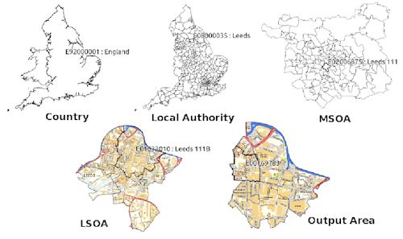

The geographies of England and Wales, from Country to Output Area[34]

### Implementation of trials

The process for creating aggregated electrical 11kV demands and 19barg gas demands based on linking the model network to Output Areas is shown in the diagram below. This process applies to both Scenario 1 (current day) and Scenario 2 (decarbonised). The treatment method described above for allocating appropriate values to the demand variables based on the scenario type is incorporated into the process.

The base demand aggregation unit in the method is the Output Area (or more likely the Lower-layer super output area) which gives the number of buildings per output area as well as other population metrics. When connected to data sources from the network operators and other published studies (e.g. nongasmap.org.uk) the number of types of demand per output area can be determined and linked to the appropriate network demand nodes.

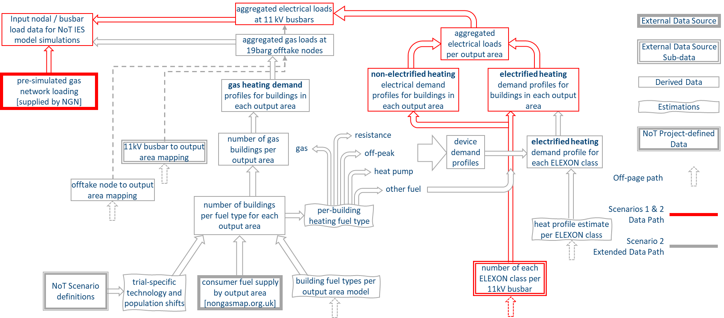

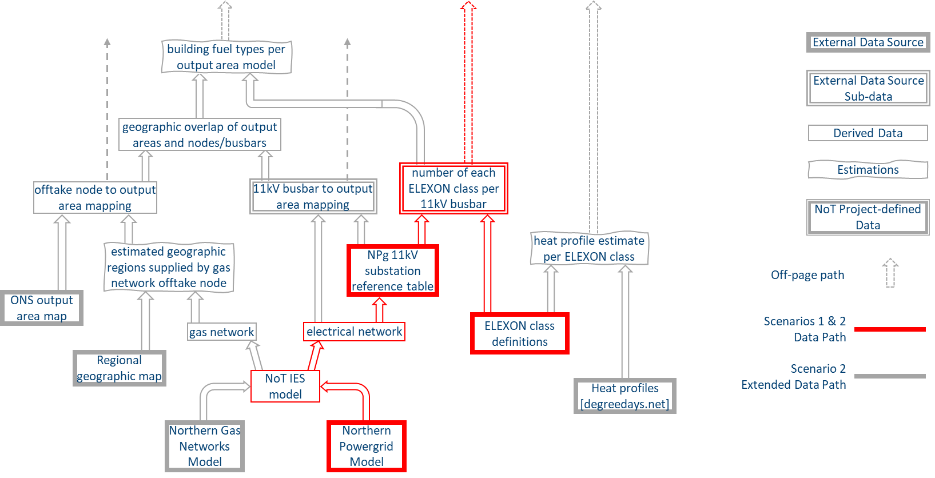

1. <https://research.ncl.ac.uk/integrel/>
2. Satellite map from <http://www.google.co.uk/maps>
3. Electrical schematic diagram from Northern Powergrid (Northeast) LTDS May 2019, Appendix 2m
4. Gas network schematic diagram from Northern Gas Networks LTDS 2019, Appendix 4
5. Hosseini, Seyed, Allahham, Adib & Taylor, Phil. (2018). Techno-Economic-Environmental Analysis of Integrated Operation of Gas and Electricity Networks. 1-5. 10.1109/ISCAS.2018.8351704.
6. TNEI Services Ltd
7. Documented on CESI NoT Teams Sharepoint site
8. ISO 6976:1995. “Natural gas-calculation of calorific values, density, relative density and index from composition”.[
9. Osiadacz, A., 1987. Simulation and analysis of gas networks. E.&F.N. Spon Ltd.
10. An, S., Li, Q. and Gedra, T.W., 2003, September. Natural gas and electricity optimal power flow. In Transmission and Distribution Conference and Exposition, 2003 IEEE PES (Vol. 1, pp. 138-143). IEEE.
11. Osiadacz, A., 1987. Simulation and analysis of gas networks. E.&F.N. Spon Ltd.
12. Narrative Scenarios for the North of Tyne Energy System by Claire Copeland, available here: <https://www.ncl.ac.uk/media/wwwnclacuk/cesi/files/Copeland%20-%20Narrative%20Scenarios%20for%20North%20of%20Tyne%20Energy%20System.pdf>
13. [North of Tyne Network Map](https://umap.openstreetmap.fr/en/map/stella-north-and-stella-south-electricity-networks_429509#11/54.9526/-1.7290) Created with UMap for Open Street Maps
14. MPAN profiles are applied to the Balancing and Settlement Code for electricity settlement, described in detail here: <https://www.elexon.co.uk/documents/training-guidance/bsc-guidance-notes/load-profiles/>
15. More detailed information on the sampling process and profile generation methodology can be found here: <https://www.elexon.co.uk/operations-settlement/profiling/>
16. Economy 7 customers have two different electricity meters installed at the property, and receive a much cheaper price for electricity used at night (for a consecutive 7 hour period between 10.30pm-8.30am). Economy 7 tariffs are commonly installed in properties that are only connected to the electricity network, and therefore might have hot water tanks or electric storage heaters.
17. CREST Demand Model <https://www.lboro.ac.uk/research/crest/demand-model/>
18. Community energy modelling by Mcallum et al. <https://www.sciencedirect.com/science/article/pii/S0301421519304112>
19. <https://www.gov.uk/government/statistics/lsoa-estimates-of-households-not-connected-to-the-gas-network>
20. Mapped here: <https://www.nongasmap.org.uk/>
21. Supplied by colleagues from Northern Powergrid
22. Data set from ELEXON – check reference
23. Northern Powergrid DFES
24. Northern Powergrid DFES
25. <https://www.ons.gov.uk/census/2001censusandearlier/dataandproducts/outputgeography/outputareas>
26. <https://data.gov.uk/dataset/e9e8e348-9dff-45f6-a899-b0aa1d9af616/housing-stock>
27. <https://www.gov.uk/government/statistical-data-sets/live-tables-on-energy-performance-of-buildings-certificates>
28. <https://www.gov.uk/government/collections/fuel-poverty-sub-regional-statistics>
29. <https://www.ons.gov.uk/census/2011census/2011censusdata/2011censusdatacatalogue>
30. <https://www.nomisweb.co.uk/census/2011/bulk/r2_2>
31. <https://www.ons.gov.uk/employmentandlabourmarket/peopleinwork/employmentandemployeetypes/methodologies/claimantcountqmi>
32. <https://www.gov.uk/government/statistics/english-indices-of-deprivation-2019>
33. <https://www.gov.uk/government/statistics/2011-rural-urban-classification>
34. <https://census.ukdataservice.ac.uk/use-data/guides/boundary-data.aspx>